**Wifi Pineapple: Evil Portal**

Plug the Wifi Pineapple into your device or power source

Open a web browser and navigate to 172.16.42.1:1471

Login to the Wifi Pineapple

On the left hand side of the screen there is a taskbar. Select the sixth option that looks like a puzzle piece to bring up the Modules & Packages tab.

Navigate to the Available Modules tab at the top of the screen and click the button labelled “Get Available Modules”.

Select the Evil Portal module and install it to the Wifi Pineapple. Then navigate to the Installed Modules tab at the top of the screen.

Click on the Evil Portal box to bring up the Evil Portal tab.

You can either create a new portal or add a portal to the Portal Library using a USB. (Instructions on how to add portals using a USB are added at the end of these instructions)

Once a portal is added, in the Portal Library tab you can see the list of portal names. You can download, preview, or view log of each portal. To enable the portal, select the Activate option.

Then make sure that Start and Start Web Server is selected at the top of the screen.

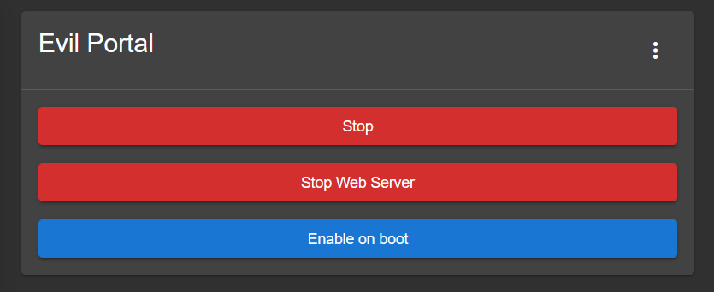

Now when devices connect to the Wifi Pineapple’s access point, it should bring up a login page.

You can see the login information by viewing the log for the portal.

**How to add the evil portal templates from a USB device**

Go to the Wifi Pineapple Evil Portal Templates folder on the Google drive and copy the evilportals-master folder onto a USB device. Insert the USB device into the Wifi Pineapple. Log into the Wifi Pineapple and click on the terminal icon at the top right corner of the screen next to the icon of the three vertical dots.

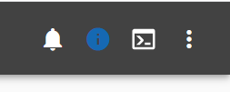

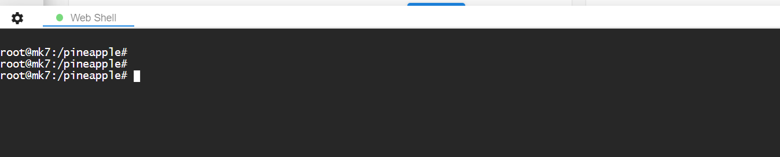

Navigate to the USB file location and copy the contents of the evilportals-master folder using the following command:

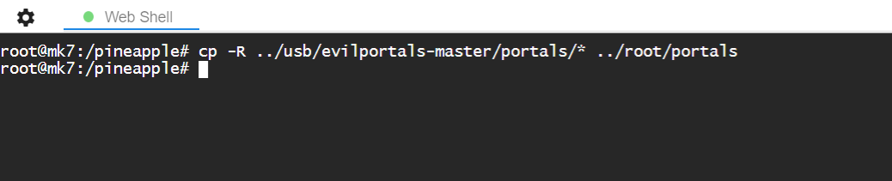

Now the portal templates should be displayed in the Evil Portal tab on the Wifi Pineapple.

